Given a tree (i.e. a connected, undirected graph that has no cycles) consisting of n nodes numbered from 0 to n - 1 and exactly n - 1 edges. The **root** of the tree is the node 0, and each node of the tree has **a label** which is a lower-case character given in the string labels (i.e. The node with the number i has the label labels[i]).

The edges array is given on the form edges[i] = [ai, bi], which means there is an edge between nodes ai and bi in the tree.

Return *an array of size n* where ans[i] is the number of nodes in the subtree of the ith node which have the same label as node i.

A subtree of a tree T is the tree consisting of a node in T and all of its descendant nodes.

**Example 1:**

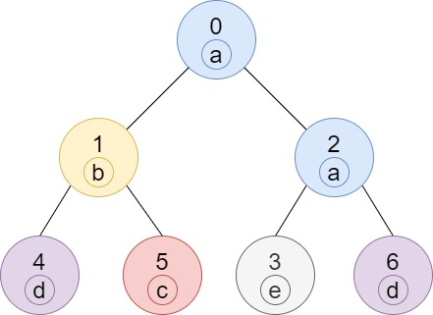

**Input:** n = 7, edges = [[0,1],[0,2],[1,4],[1,5],[2,3],[2,6]], labels = "abaedcd"

**Output:** [2,1,1,1,1,1,1]

**Explanation:** Node 0 has label 'a' and its sub-tree has node 2 with label 'a' as well, thus the answer is 2. Notice that any node is part of its sub-tree.

Node 1 has a label 'b'. The sub-tree of node 1 contains nodes 1,4 and 5, as nodes 4 and 5 have different labels than node 1, the answer is just 1 (the node itself).

**Example 2:**

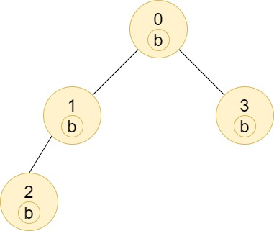

**Input:** n = 4, edges = [[0,1],[1,2],[0,3]], labels = "bbbb"

**Output:** [4,2,1,1]

**Explanation:** The sub-tree of node 2 contains only node 2, so the answer is 1.

The sub-tree of node 3 contains only node 3, so the answer is 1.

The sub-tree of node 1 contains nodes 1 and 2, both have label 'b', thus the answer is 2.

The sub-tree of node 0 contains nodes 0, 1, 2 and 3, all with label 'b', thus the answer is 4.

**Example 3:**

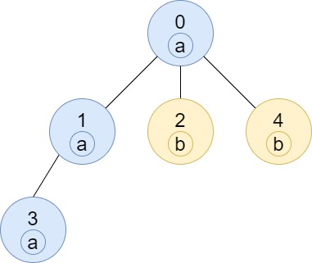

**Input:** n = 5, edges = [[0,1],[0,2],[1,3],[0,4]], labels = "aabab"

**Output:** [3,2,1,1,1]

**Example 4:**

**Input:** n = 6, edges = [[0,1],[0,2],[1,3],[3,4],[4,5]], labels = "cbabaa"

**Output:** [1,2,1,1,2,1]

**Example 5:**

**Input:** n = 7, edges = [[0,1],[1,2],[2,3],[3,4],[4,5],[5,6]], labels = "aaabaaa"

**Output:** [6,5,4,1,3,2,1]

**Constraints:**

* 1 <= n <= 10^5
* edges.length == n - 1
* edges[i].length == 2
* 0 <= ai, bi < n
* ai != bi
* labels.length == n
* labels is consisting of only of lower-case English letters.